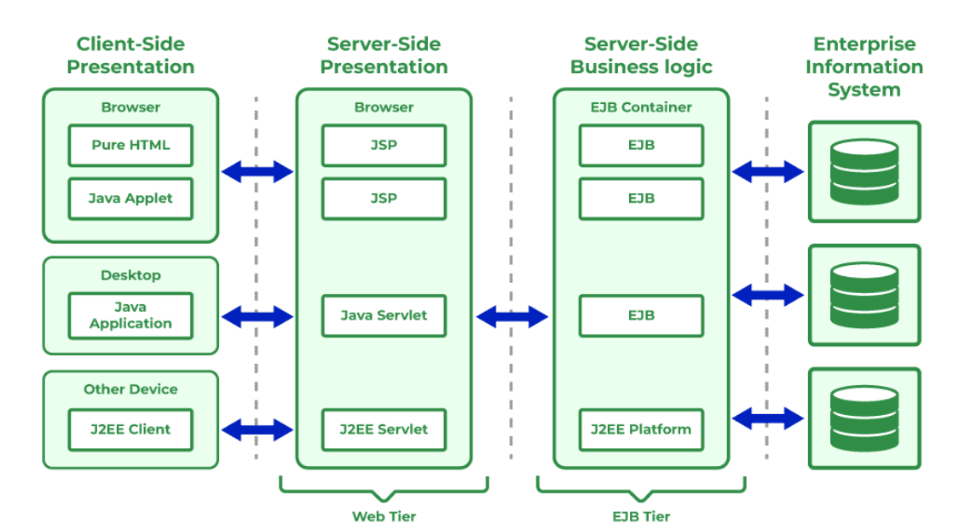

The J2EE architecture is traditionally organized into four distinct tiers or layers. Here is how each layer functions:

1. The Client Tier (or Presentation Interface)
This is where the user interacts with the application. The client requests resources from the server.

Components: Web Browsers (using HTML/CSS/JS), Applets (legacy), or Standalone Java applications.

Responsibility: Displaying the user interface (UI) and sending user inputs (requests) to the server. It does not process business logic.

2. The Web Tier (or Presentation Layer)
This layer acts as the entry point for web-based clients. It manages the flow of the application and handles the user interface logic.

Key J2EE Components: Servlets and JavaServer Pages (JSP).

Responsibility:

Receives HTTP requests from the client.

Processes UI-related logic (like session management).

Creates the dynamic HTML response that is sent back to the browser.

Communicates with the Business Tier to fetch data.

3. The Business Tier (or Business Logic Layer)
This is the "brain" of the application. It contains the core logic required to solve the business problem.

Key J2EE Component: Enterprise JavaBeans (EJB). (Also often managed by frameworks like Spring in modern iterations).

Responsibility:

Executes complex business rules and calculations.

Manages transactions (ensuring data integrity).

Coordinates interactions between the Web Layer and the Data Layer.

Typically runs on an EJB Container within an Application Server (like WildFly or GlassFish).

4. The Enterprise Information System (EIS) Tier (or Data Layer)
This is where the application's persistent data resides.

Key Components: Relational Databases (Oracle, MySQL), Legacy Systems, or Enterprise Resource Planning (ERP) systems.

Connectivity: J2EE uses JDBC (Java Database Connectivity) and JTA (Java Transaction API) to interact with this layer.

Responsibility: Storing, retrieving, and managing the persistent data of the application.

Key Takeaways for your Assignment
Separation of Concerns: The main goal of this architecture is to separate the UI (Presentation) from the calculation (Business) and the storage (Data). This means if you change the database, you don't need to rewrite the UI.

Containers: Each component (Servlets in the Web Tier, EJBs in the Business Tier) runs inside a Container (Web Container, EJB Container). The container provides necessary services like security, transaction management, and lifecycle management.

Scalability: Because the layers are separate, you can scale them independently. For example, if many users visit the site, you can add more servers to the Web Tier without touching the Data Tier.

